Approx. 1272 words)

Exploring Your Windows PC
By Dick Maybach, Brookdale Computer User Group
www.bcug.com
n2nd (at) att.net
Becoming familiar with your PC is like becoming familiar with a foreign city. You can read a book about it or visit it, but it's far better to do both; a visit gives you first-hand views of the landscape that you aren't likely to forget, and a book helps you understand what they mean. For becoming familiar with Windows, I like the book Windows 10 In Depth by Brian Knittel and Paul McFedries; although at $40 and almost 1000 pages, it's neither a cheap nor a quick read. Windows 10 comes with many tools you can use to tour its terrain. Spending time visiting while your PC is working well not only removes a lot of the mystery of what it does but can help significantly if you run into problems.

The Task Manager is a good place to begin. Type "task" in the search box at the bottom left and select Task Manager on the right of the window that appears. (In the rest of this article, I'll replace the words describing such operations with the shortcut "task"> Task Manager.) Figure 1 shows the Task Manager's Processes tab, which shows what is running. Note the down-arrow at the top of the CPU column, which shows that the tasks are sorted by CPU usage. You can select any column to sort by its quantity. By the way, the 100% on the Disk column means neither that the disk is full nor that it's transferring data at maximum capacity, but only that it's always active. A right-click on a task name will display a menu of actions, and one that I've found helpful is End task, which shuts it down.

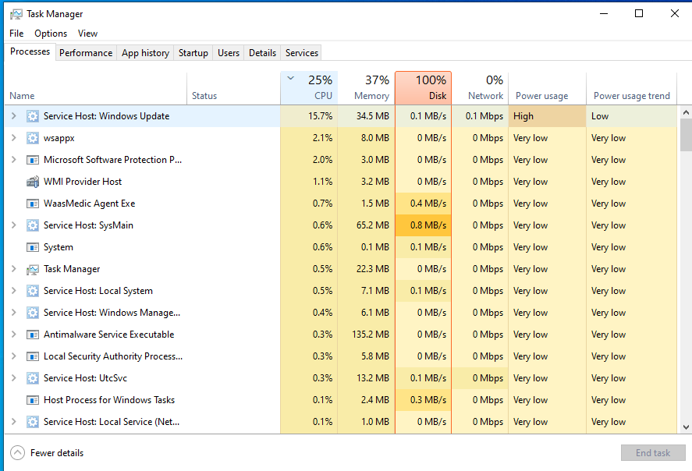

Figure 1. Task Manager, Processes Tab.

Figure 2 shows the Performance tab, where the CPU item on the left has been selected to show an overview of CPU activity. You can also see similar memory, disk, and network displays.

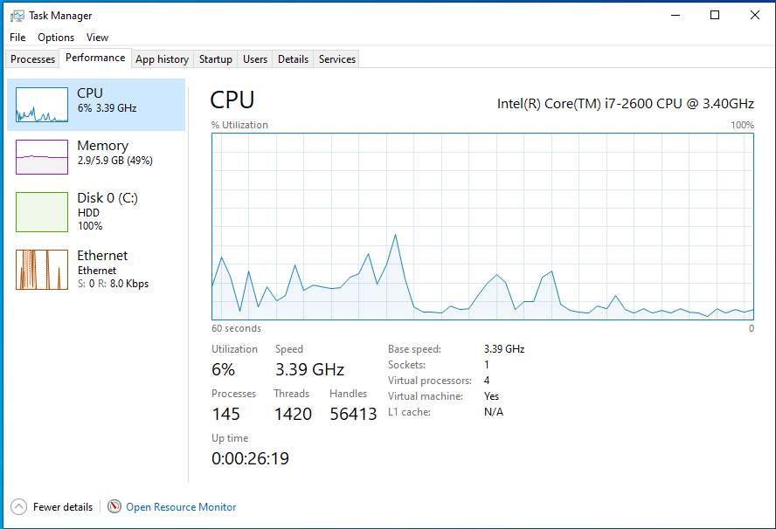

Figure 2. Task Manager, Performance Tab.

The App history tab shows what your PC has been doing, including what resources each process has used, Figure 3.

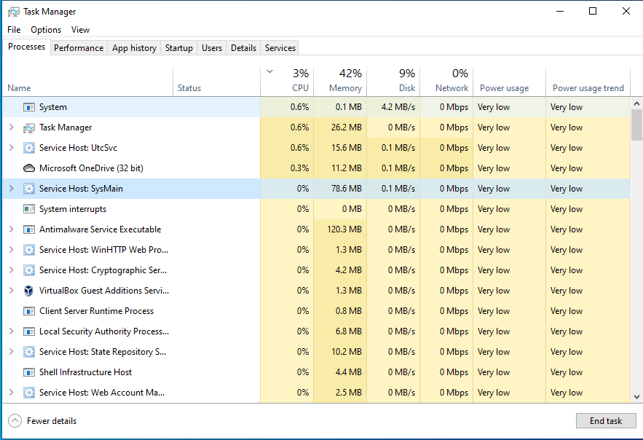

Figure 3. Task Manager, App History Tab.

The Resource Monitor ("resource" > Resource Monitor) is similar to Task Manager but shows more details. Figure 4 shows its Overview tab. As you can tell from the scrolling bars on the right, only a portion of each text panel is displayed here. (The network wasn't being used, so I haven't displayed that window. You can show or hide any window by selecting its title bar.) As with the Task Manager, you can right-click on an activity to bring up a menu of actions.

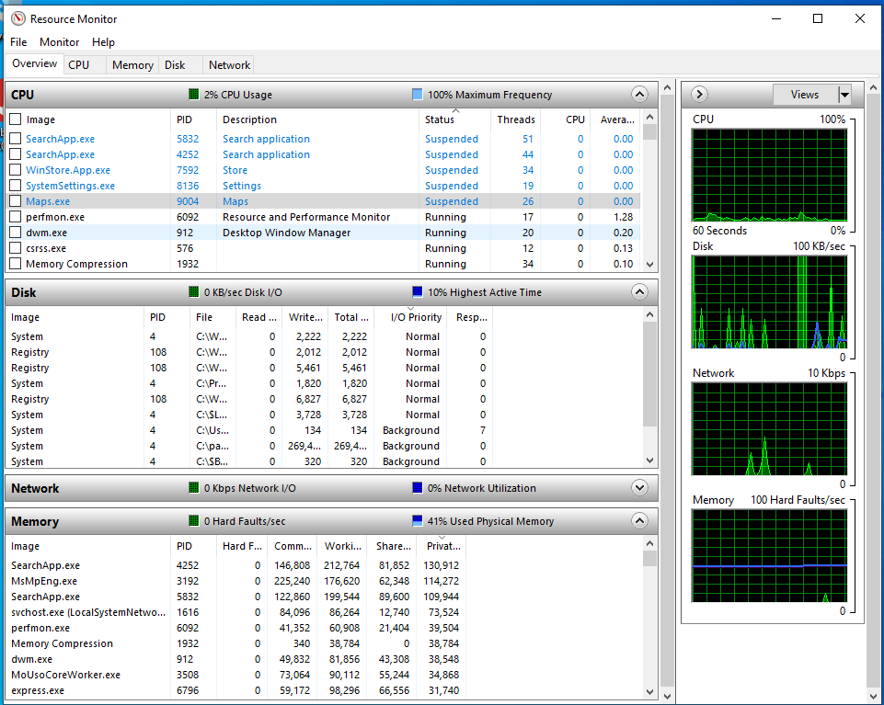

Figure 4. Resource Monitor, Overview Tab.

The CPU tab shows that activity. This instance of Windows is running on a virtual machine with four processors, and Figure 5 shows the activity on each, although there wasn't room in the window for CPU 4.

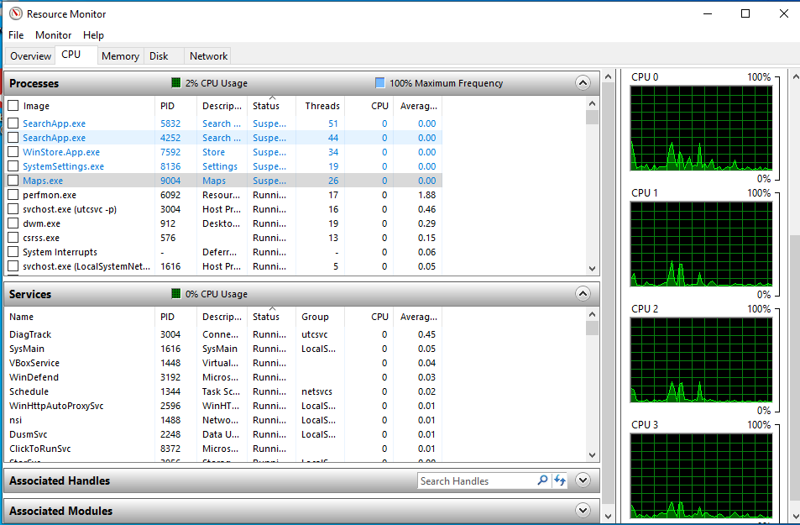

Figure 5. Resource Monitor, CPU Tab.

Similarly, the Memory tab displays details of your RAM use, as shown in Figure 6. (Faults don't indicate problems; they mean data wasn't in a cache and had to be retrieved from RAM.) Finally, note the memory use summary at the bottom of the window.

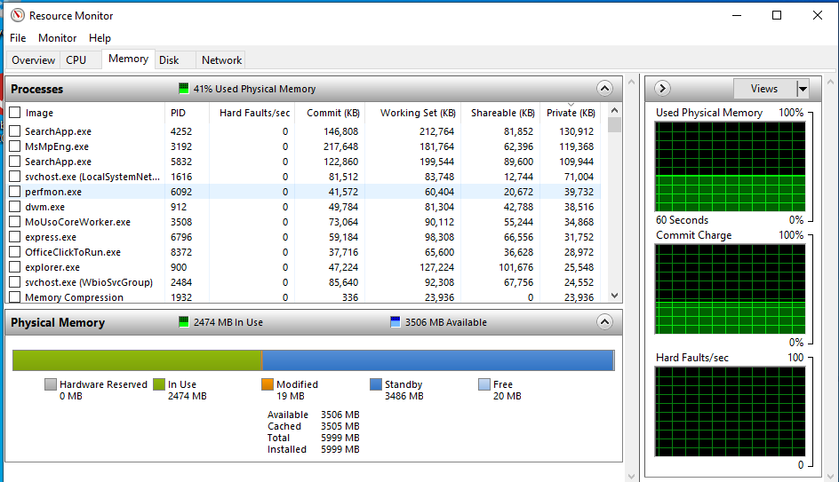

Figure 6. Resource Monitor, Memory Tab.

The Security and Maintenance tool ("maintenance"> Security and Maintenance) will display and help you resolve many problems. Figure 7 shows the usual case. Before taking this screenshot, I selected the Security and the Maintenance items to display those details. As you can infer from the scroll bar, only a portion of the window is visible,

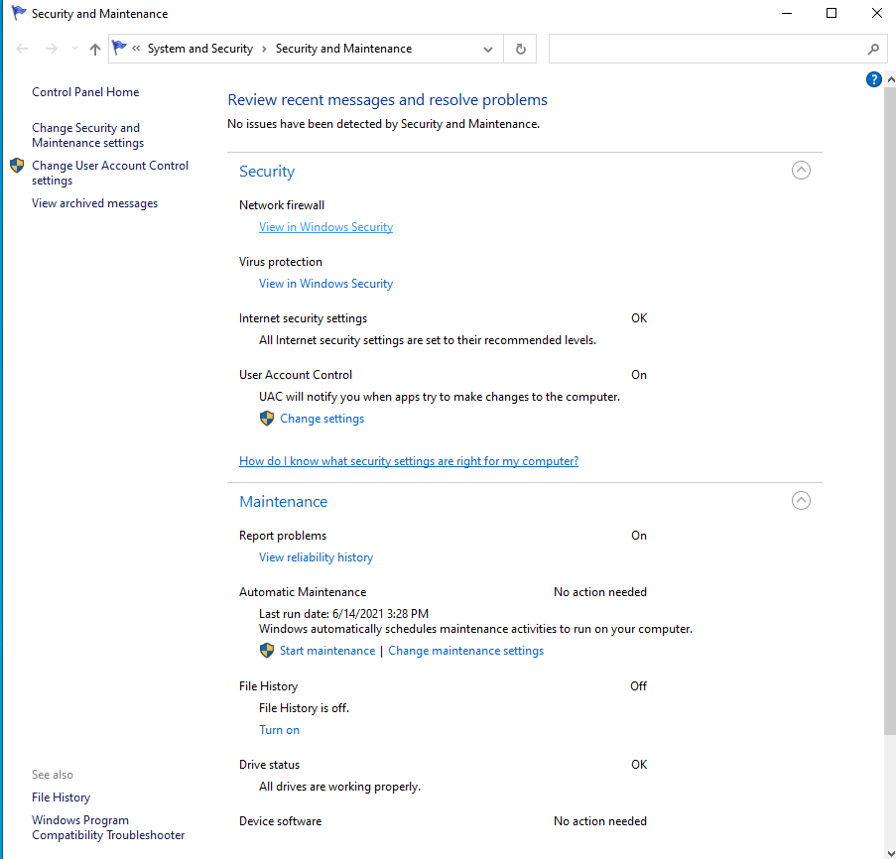

Figure 7. Security and Maintenance Tool.

Storage Settings ("storage"> Storage Settings) shows your hard disk usage, Figure 8. (Turning Storage Sense On automatically deletes temporary files.) The small hard disk here is because this PC is a virtual machine. You will have to select "Show more categories" to see more than the Apps & features and Temporary files items. Select a blue icon on the left to display the details of that category.

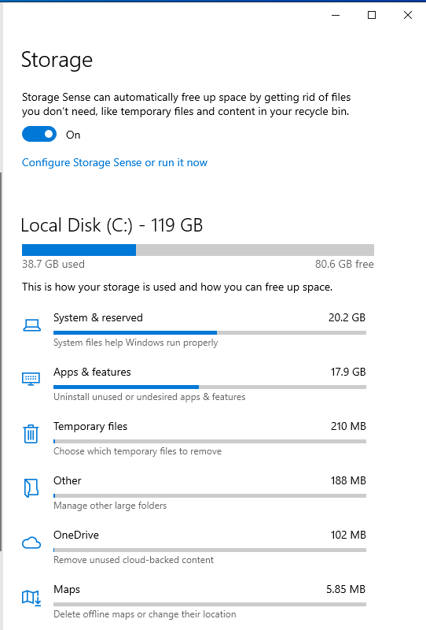

Figure 8. Storage Settings.

You can see another view of your hard disk use by looking at its properties ("file"> File Explorer > Right-click on Local Disk (C:) > Properties), Figure 9. From here, you can also compress your disk (which will slow it down), clean it up by removing unneeded files, check for errors, defrag the file system, and change the security settings.

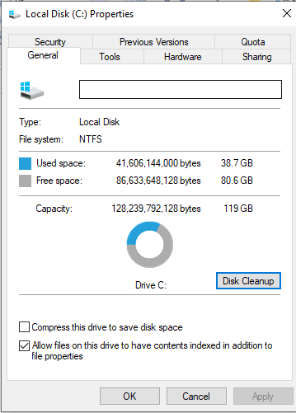

Figure 9. Local Disk Properties.

System Information ("msinfo32"> System Information) can tell you many system details, but understanding the information requires considerable expertise, Figure 10. However, exploring here is much safer than wandering through the Registry. In addition, you can find information on your hardware and software much faster than by opening the system case.

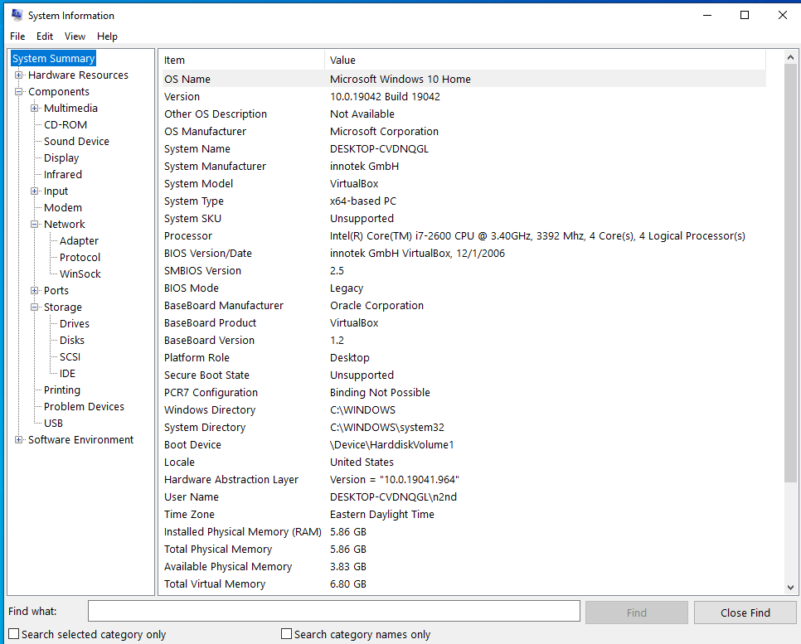

Figure 10. System Information.

If you have a problem, you can ask Windows to help you solve it ("trouble"> Troubleshoot Settings), Figure 11. Don't expect miracles, but it's worth trying before you begin more time-consuming or expensive measures. The Additional troubleshooters item lets you direct the program toward the area of difficulty.

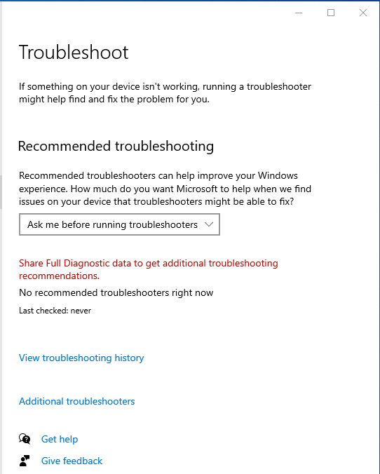

Figure 11. Troubleshoot Settings.

You can see, and uninstall if you like, the programs you've installed with the Apps & Features utility ("programs"> Apps & Features > go to the bottom of the page > Programs and Features), Figure 12.

Displays the software you (and Microsoft) have added after Windows was installed. But, again, we're looking at a virtual machine, and the number of apps is far smaller than usual.

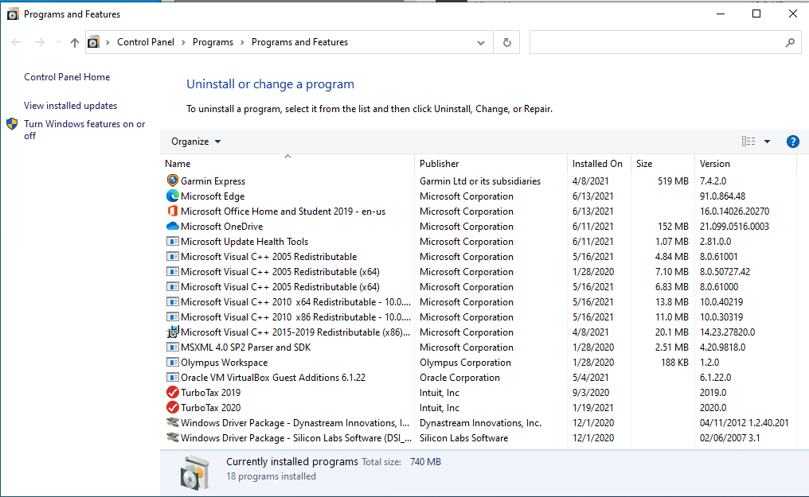

Figure 12. Apps & Features.

Network Status ("network"> Network Status) shows your network's status, usage, and devices, Figure 13.

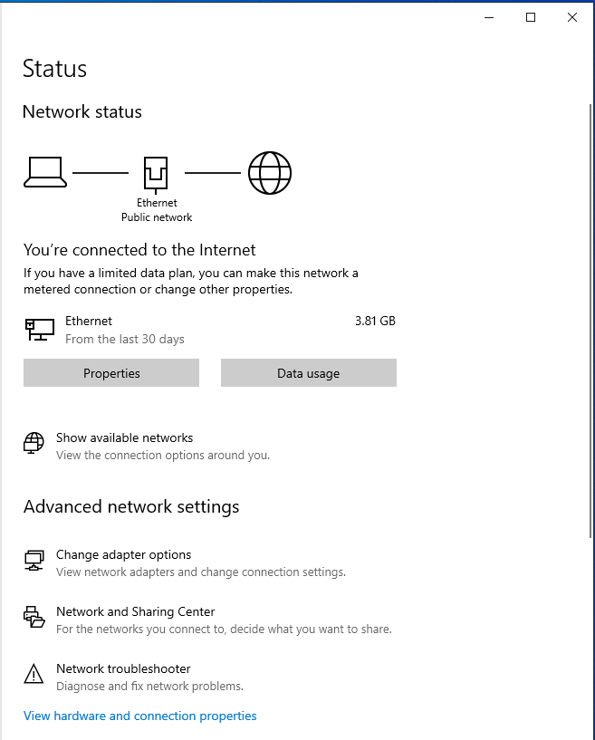

Figure 13. Network Status.

A firewall ("firewall"> Windows Defender Firewall) is your first defense against hackers, Figure 14. This screen shows the type of network connection and whether the firewall is active. This is less important at home, where you operate behind the hardware firewall in your Ethernet modem. However, if your PC is a laptop that you use at public hot spots, be sure to check that your firewall is set up correctly.

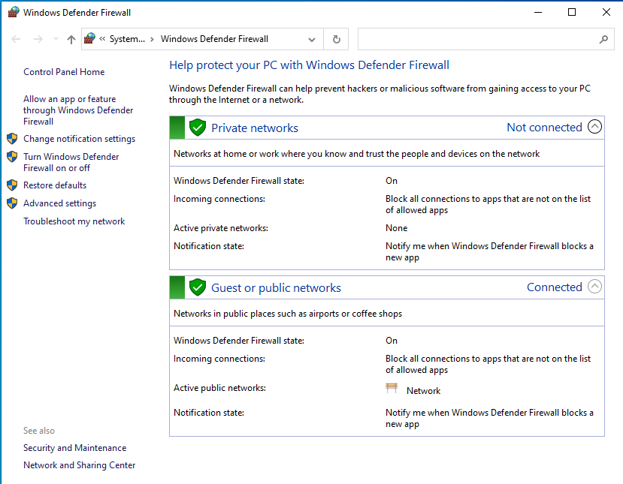

Figure 14. Windows Defender Firewall.

Settings ("settings"> Settings) is a central location for configuring your PC. We've already seen many of the topics displayed in Figure 15 by going directly to them. You've no doubt already done this, but it's worth revisiting to be sure you have missed something. In particular, Phone lets you link your PC with an Android device. Other worthwhile items are Network (which shows the devices and history of use), Ease of Access (which lets you customize to accommodate impaired perception), and Privacy (which sets how much info you disclose to MS and websites). Finally, Update & Security controls the updating process.

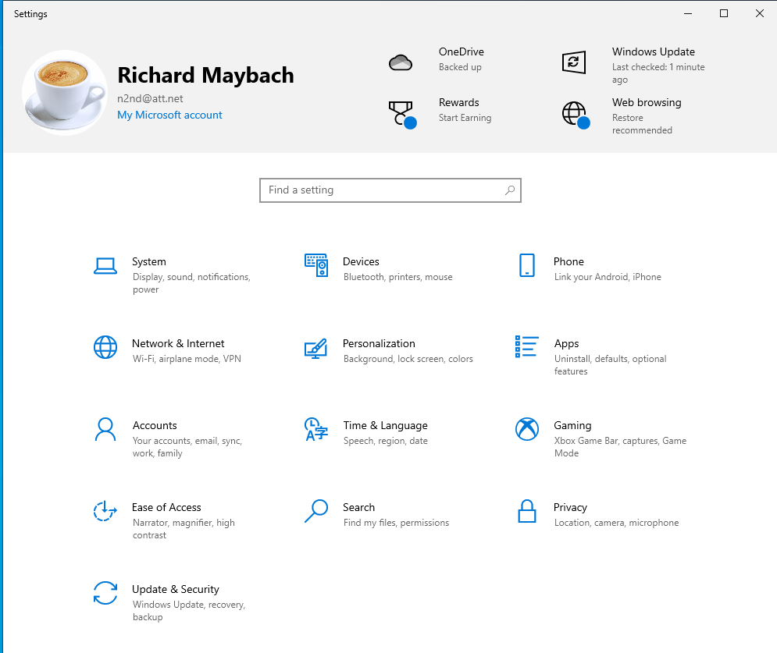

Figure 15. Settings Window.

The Device Manager ("device"> Device Manager) shows the device items from the Registry. You can view the devices by type (the view in Figure 16), by connection, or by container, as well as the resources by type or connection. You can also update drivers. Of course, you'll need some experience to do anything worthwhile or even safely here.

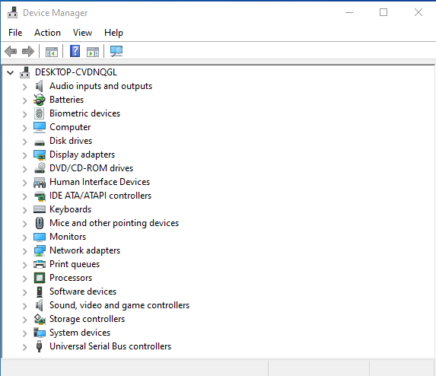

Figure 16. Device Manager Window.

You should visit the Registry ("registry"> Registry Editor > Yes, to allow changes) only if you know what you're doing! See Figure 17. Since XP days, I haven't done this, and Windows 10 allows far safer ways to change its configuration. If you must work here, be sure you have everything backed up first.

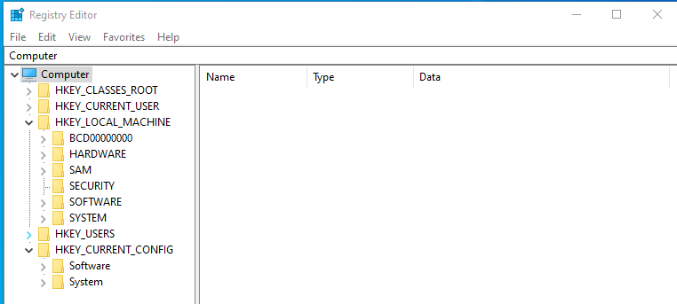

Figure 17. Registry Editor.

As you explore your PC, you'll find much that needs explanation. Consider these puzzles to be opportunities to guide your reading in a good book or your Internet searches.

